**R Code for Examples in the book**

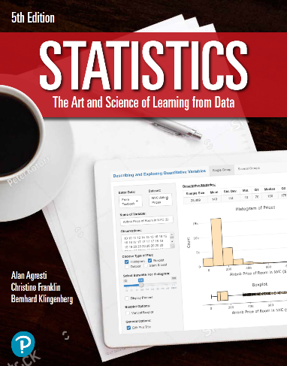

***“Statistics: The Art and Science of Learning from Data”***

**by Agresti, Franklin and Klingenberg, 5th edition**

**Chapter 2**

**Example 12: Ideal Number of Children – Standard Deviation**

## Read in values:

men <- c(0, 0, 0, 2, 4, 4, 4)  
women <- c(0, 2, 2, 2, 2, 2, 4)

## Dotplot for values for men

library(ggplot2)  
ggplot(data.frame(men), aes(x = men)) +   
 geom_dotplot() +  
 labs(x = '',  
 title = 'Dotplot', subtitle = 'Men') +  
 theme_classic() +  
 theme(axis.line.y=element_blank(),  
 axis.text.y=element_blank(),  
 axis.ticks.y=element_blank(),  
 axis.title.y=element_blank()  
 )

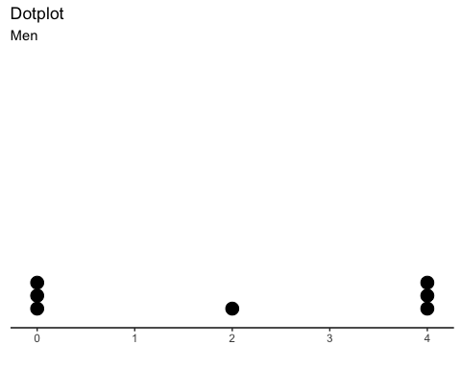

## Dotplot for values for women

ggplot(data.frame(women), aes(x = women)) +   
 geom_dotplot() +  
 labs(x = '',  
 title = 'Dotplot', subtitle = 'Women') +  
 theme_classic() +  
 theme(axis.line.y=element_blank(),  
 axis.text.y=element_blank(),  
 axis.ticks.y=element_blank(),  
 axis.title.y=element_blank()  
 )

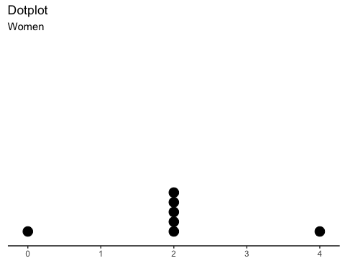

## To find the Standard Deviation

sd(men)

## [1] 2

sd(women)

## [1] 1.154701